Họ và tên: Lê Bá Khánh Trình

MSSV: 6151071108

**BUỔI 4B**

a. Retrieve the name and address of patients who live in Hanoi and treated by Dr. Jaspal. 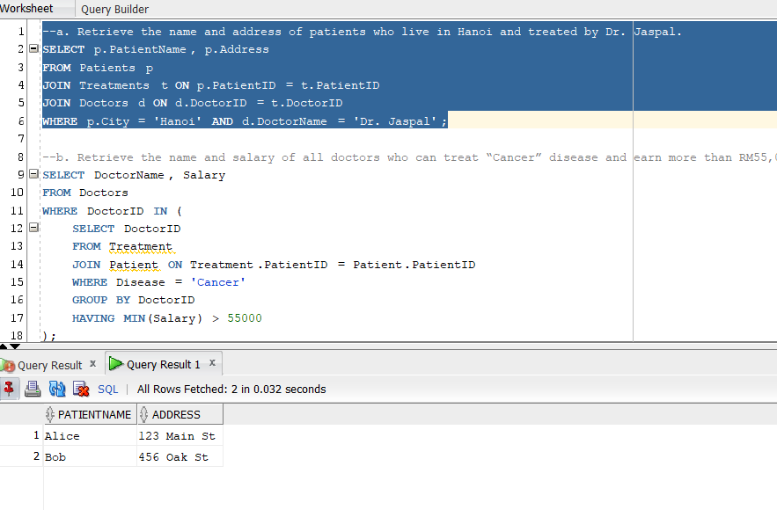

b. Retrieve the name and salary of all doctors who can treat “Cancer” disease and earn more than RM55,000. 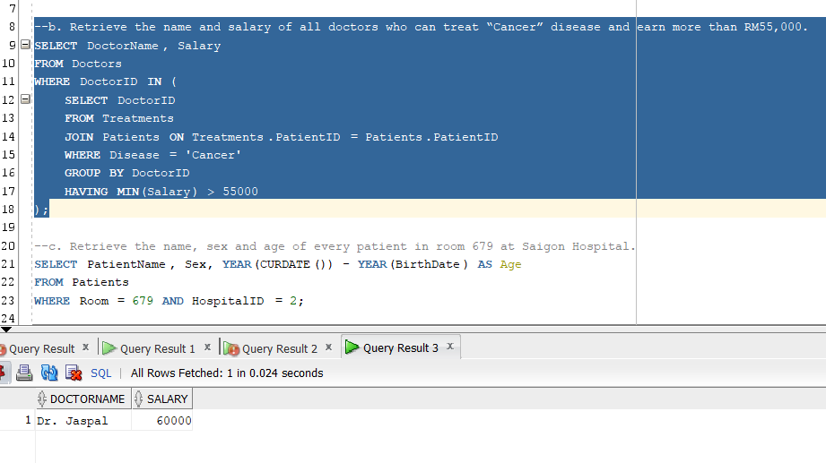

c. Retrieve the name, sex and age of every patient in room 679 at Saigon Hospital. 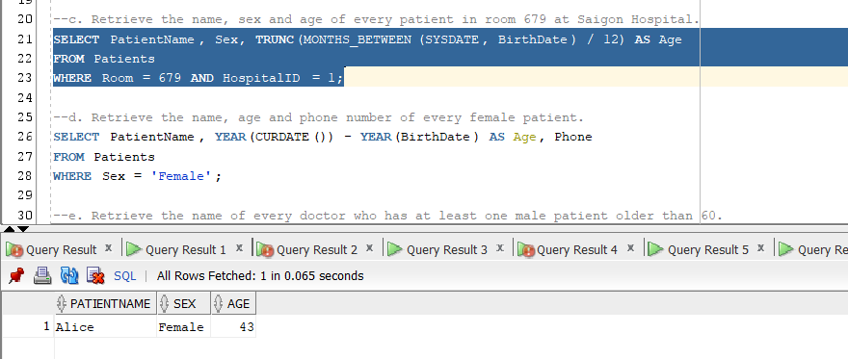

d. Retrieve the name, age and phone number of every female patient. 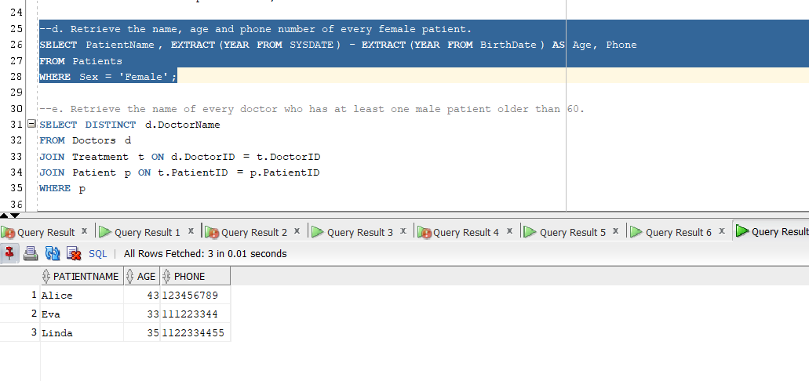

e. Retrieve the name of every doctor who has at least one male patient older than 60. 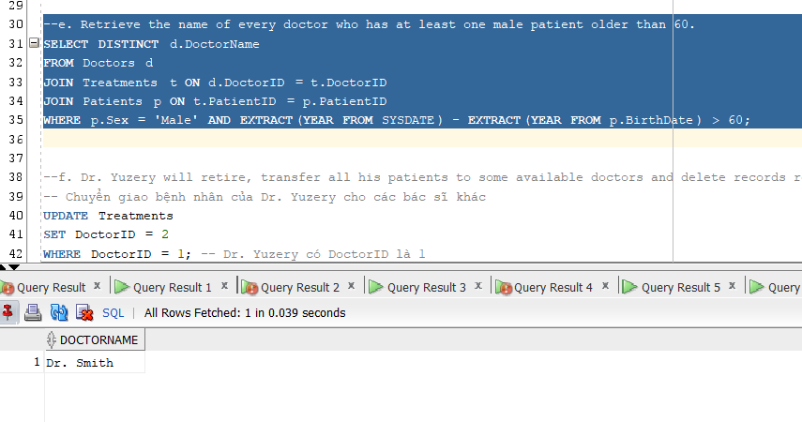

f. Dr. Yuzery will retire, transfer all his patients to some available doctors and delete records relating to him. Make sure that all constraints are met. 